Group id : A6

Project Name : Stock Candle

**Assignment 8**

Title: Prepare a DFD Diagram

Problem Statement: draw the DFD using proper notations.

Theory :

DFD

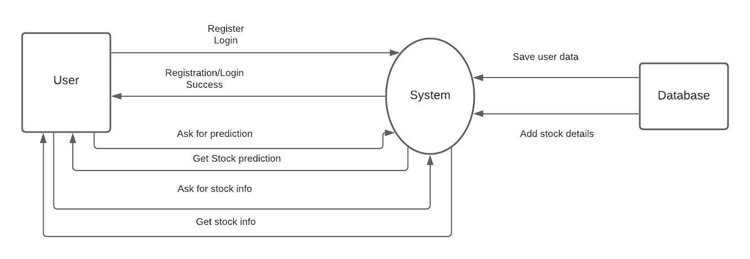

**Conclusion :** Thus, we have prepared uml DFD using advanced uml2 notations and lucid chart.